User Manual for 1080P Spy Pen Camera
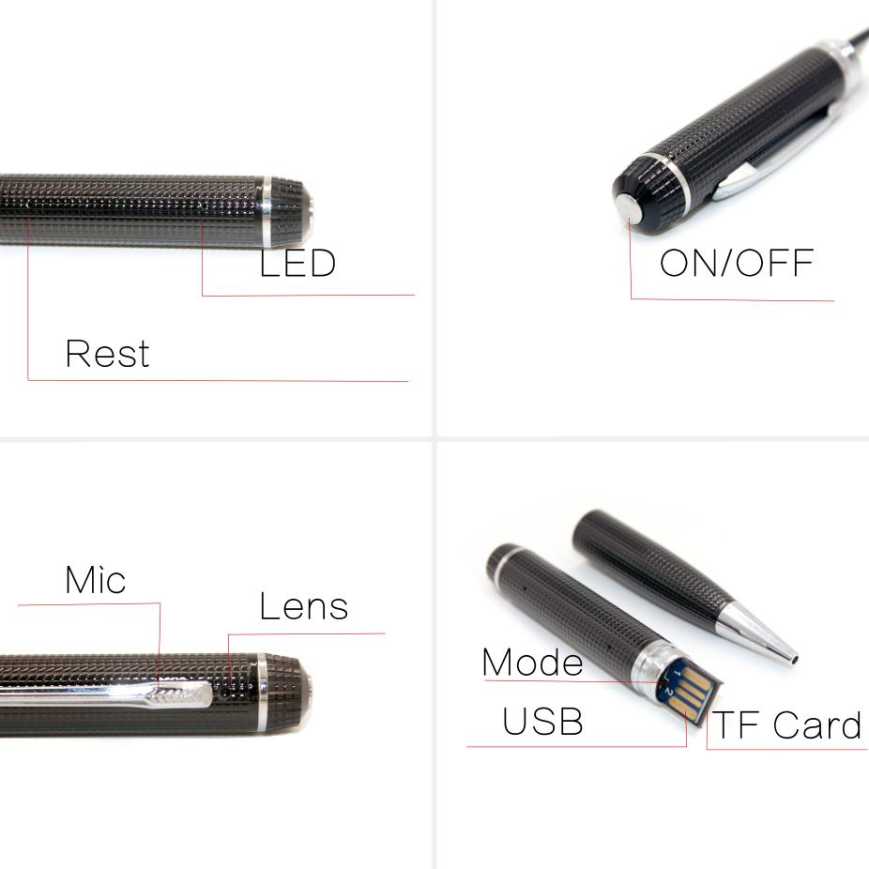
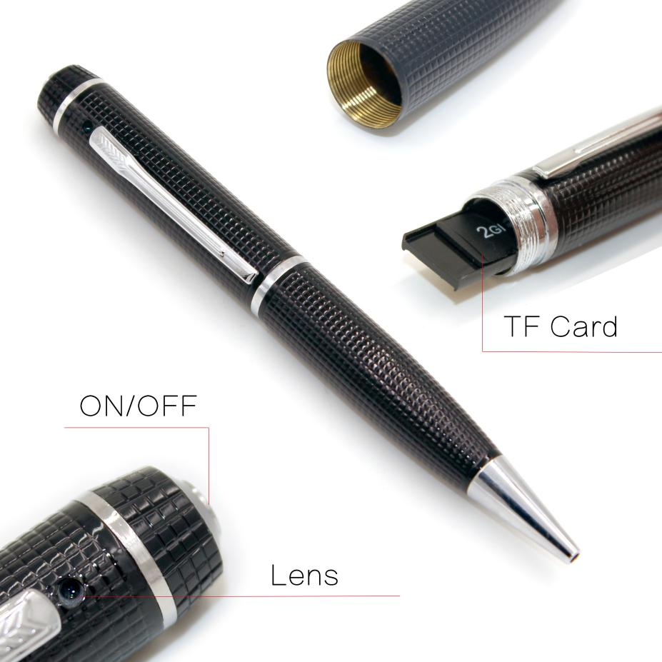
- Preparation
The device only supports TF card with FAT32 format. Before installation, please choose FAT32 file system and format the card on your computer. NTFS and exFAT are not supported for the moment.
Note: If you are Mac computer users, you need to take the memory card out and connect it to your computer with a card reader, then you can access the files.

- Video Recording
- Please insert a TF card in a correct way, and toggle the switch to mode 2.
- Please long press the power button for 2 seconds to turn on the device. After the yellow and blue light flashes alternately, the blue light will flash 3 times and then go out. Now the device enters the video recording mode.
- Please short press the power button to save the recording. Then the yellow light will be turned on. Please press the power button again, and the blue light will flash 3 times and goes out. Now the device starts recording automatically.
Note: The video format is AVI (1920*1080 Resolution),better use 16G/32G TF card, 16GB TF card can save 10 minutes video, 32GB TF card can save 20 minutes video.

- Audio Recording & Snapshot
- Please insert a TF card in a correct way, and toggle the switch to mode 1.
- Please long press the power button for 2 seconds to turn on the device. Now the device enters the automatic audio recording mode. Please short press the power button and the yellow light will turn on, which indicates the device stops audio recording and enters the snapshot mode. C. Please press the power button once, and the blue light will flash once, which means a snapshot has been taken.
Note: The snapshot photo’s format is JPEG (2560*1440 Resolution).

- Power Off
Please long press the power button for 3 seconds, and the device will be turned off automatically.

5. Time Settings
Please create a time.txt file in your TF card, change the time of the file to the current time and save it.

6. Charging
Please unscrew the pen, insert the device’s USB port into the computer or USB charger. The yellow light will flash during charging; it will be turned on after the device is fully charged.

7.Reset
When resetting, please use a non-metallic hard thin rod to insert the reset hole, then gently press the reset button to reset. After the resetting is completed, the device will be powered off.

